Registration URL with POST request. Required body params: username, password, password_confirmation

<https://web-api.nagadhat.com.bd/api/nh-registration>

Verify registration OTP with POST request. Required body params: username, user_otp

<https://web-api.nagadhat.com.bd/api/registration-otp-verify>

Login URL with POST request. Required body params: username, password

<https://web-api.nagadhat.com.bd/api/nh-login>

Create new brand with POST request. Required body params: title, slug, logo

<https://web-api.nagadhat.com.bd/api/create-brand>

Get all brand list with GET request. You should replace the {Limit} with all or integer number like 1, 2, 3.

[https://web-api.nagadhat.com.bd/api/get-brand/{Limit}](https://web-api.nagadhat.com.bd/api/get-brand/%7bLimit%7d)

<https://web-api.nagadhat.com.bd/api/get-brand/3>

<https://web-api.nagadhat.com.bd/api/get-brand/all>

Create new category with POST request. Required body params: title, slug, logo, author_id

<https://web-api.nagadhat.com.bd/api/create-category>

Get all category list with POST request. By default, this end-point will provide a short list of categories with three columns ('id', 'title', 'slug'). For full list you have to provide a body param with the key 'list_type' and value = full_list. Pass body param with the key 'slider_menu' and value = 'menu_view' to get all the categories for Slider-Menu.

<https://web-api.nagadhat.com.bd/api/all-category>

Add master product with POST request. See the attached image for required params to be submit -

<https://web-api.nagadhat.com.bd/api/add-master-product>

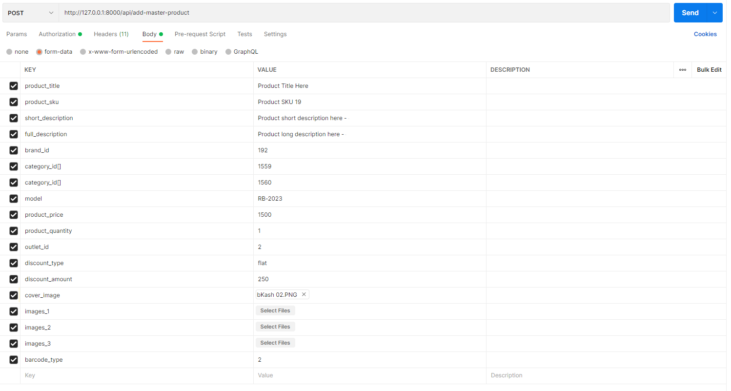

Get all product list and product_stock with GET request. You should replace the {Limit} with all or integer number like 1, 2, 3.

[https://web-api.nagadhat.com.bd/api/get-product/{Limit}](%20https://web-api.nagadhat.com.bd/api/get-product/%7bLimit%7d)

<https://web-api.nagadhat.com.bd/api/get-product/4>

<https://web-api.nagadhat.com.bd/api/get-product/all>

Create new requisition with POST request. Follow the given JSON format. You can add one or more then one object within ‘product’ array. Use outlet_id = 1

[https://web-api.nagadhat.com.bd/api/outlet-product-requisition](https://web-api.nagadhat.com.bd/api/add-master-product)

*{*

*"requisition":{*

*"outlet_id":1,*

*"product":[*

*{"product_id":114, "product_quantity":40},*

*{"product_id":115, "product_quantity":35},*

*{"product_id":116, "product_quantity":39},*

*{"product_id":117, "product_quantity":18},*

*{"product_id":118, "product_quantity":21}*

*]*

*}*

*}*

***N.B: All end-point needs authorization type bearer token except - registration, otp-verification and login.***